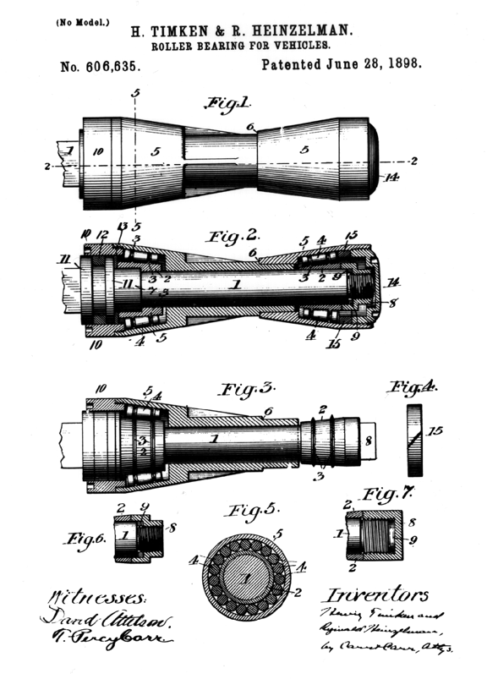
- Worldwide Leader in Bearings and Steel
- Original Equipment Manufacturer
- 90 Manufacturing Plants Worldwide
- $60M Annually in Research & Development
- World Leader In Precision Roller Bearings
- World Leader In Hub Technology
- World Leader In ABS Technology Development
- Broadest Product Offering in the World
- R&D - 10 Engineering/Technical Centers
- Leader In Automotive Wheel End Technology
- Only FAA Approved Bearing Manufacturer

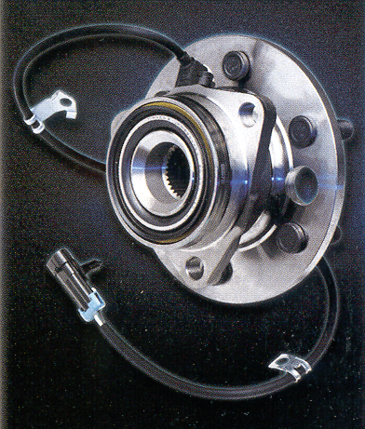

- Timken: OEM on Majority Of All Light Truck/SUV
- Timken: Quality Unmatched By Competition
- Timken: Majority Of Product From OEM Suppliers
- Timken: TWICE The Life Versus Economy Hubs
- Timken: Over 800 Hubs Plus Bearings & Seals
- Timken: Brand Preferred By Professional Installers
  - 75% Of Technicians Rated Timken A Premium Brand
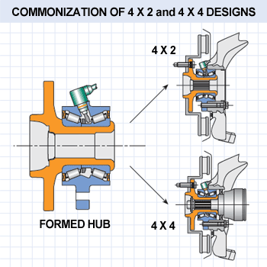
TIMKEN FIRSTS
THE FIRST With Taper Bearing Technology
THE FIRST Gen3 Tapered Hub Unit
THE FIRST With Roll Forming Technology
Eliminates Clamp Loss For Exceptional Durability

AVAILABLE AT


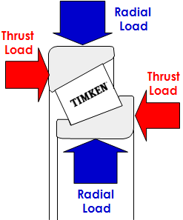
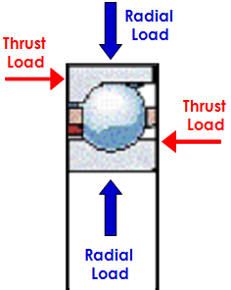
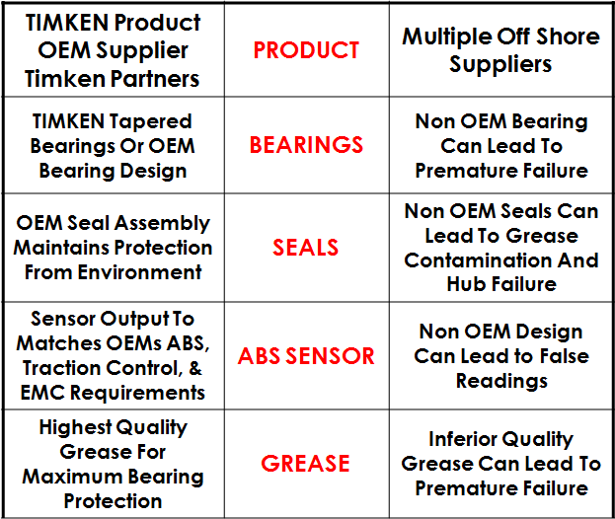

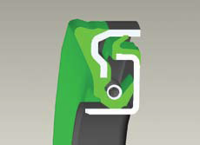
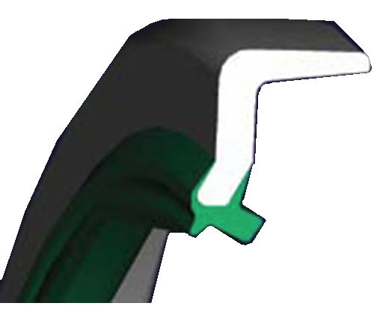

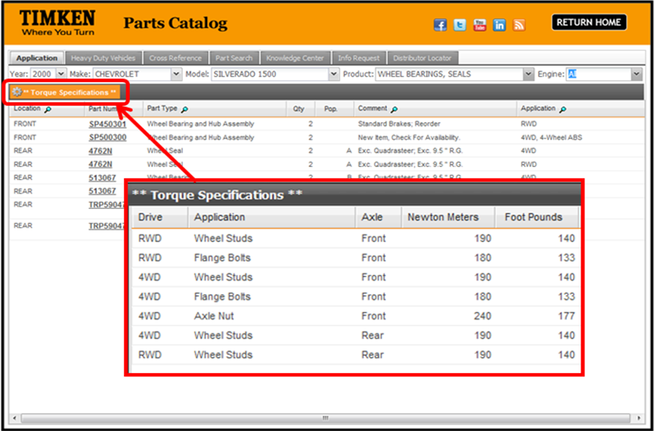
NEED TORQUE SPECS GO TO www.TIMKENINFO.COM
Go To:
TimkenInfo.com

Enter Vehicle Application Info

Then Click Box For
Torque Specification
AVAILABLE FROM
CONNOLLY SALES AND MARKETING Phone: (525) 624-2723

